SENSIBLE ANTI –THEFT CONTROLLER
USING ANESTHESIA
REASON FOR CHOOSING THIS PROJECT

- In this fast pacing world, proportional to the rate of development, crime and theft rates are also on the high.
- Normally, theft can be varied into two:
    - Hi-Tech: Eg. Stealing precious gems from museums and big jewelry shops, especially in foreign countries.
    - Old-School style: Eg. Breaking through windows, drilling through walls, breaking lockers.

SO WE NEED TO DO SOME NECESSARY STEPS TO REDUCE CRIMES

  - Should make a device which is used to secure the important Properties (money, jewels, etc,.).
  - Should make a strong alert system to suppress theft rates atleast to certain extent,
  - Should keep good communication with to arrest the thief who trying to stole the public and private properties.

- Hence, we have made this project.
PROJECT EXPLANATION

- This project mainly used as a device to avoid theft in houses, Banks and wherever the secure system needs.

- In our project “SENSIBLE ANTI-THEFT CONTROLLER USING ANESTHESIA” - using control and communication for Police. This is mainly used to avoid biro and lockers.

- We are using some special hardware such as auto-dialing unit and vibration sensor and spray unit and some emergency alert system.

The input alert unit for our project is locker damage sensing element (vibration sensor) which identifies the damage and an acknowledgement sends it to 8 bit microcontroller (microcontroller).

- The micro controller will take the immediately takes the necessary action to avoid the theft.

BLOCK DIAGRAM

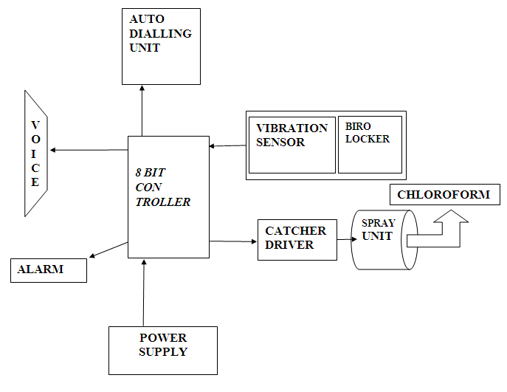

BLOCK DIAGRAM DISCRIPTION

- POWER SUPPLY
- This is basic unit which gives necessary power to the hole system

- MICROCONTROLLER
- 89S52 Microcontroller is the heart of our project.
- It acts as a master and remaining things are acts as slave. It can be control all the slave action

- AUTO DIALLING UNIT
- This is an automatic alert unit. This unit informs the theft event to local police and to the important persons.

- ALARM-VOICE
- This unit is outer alert which makes emergency alarm sound to the outer sides

- VIBRATION SENSOR
- This is locker damage sensing element (vibration sensor) which identifies the damage and an acknowledgement sends it to 8 bit microcontroller.

- SPRAY UNIT
- The controller switches the spray unit which contains chloroform.

- CHOLOROFORM
- This will affect the thieves who cannot do anything.

APPLICATION
- CAN USE AS A SECURITY SYSTEM FOR BANK LOCKERS

- AS A SECURITY SYSTEM IN HOMES – REMOTE HOUSES

- AS THIEF CATCHER AND QUICK ALERT FOR JEWELLERY SHOPS

- AS A BEST SYSTEM FOR SECURITY PURPOSE
ADVANTAGE
- Cost effective
- Automatic alert system
- Full secure for money
- Easy thief catcher
- Automatic dialing system
- Used in reserved places
CONCLUSION
- To limit crimes and robbery, there are many equipments that have been designed till date.
- The design that we’ve created is very efficient , and will be the best in the future.

